**Using the Workflow Invocation Service**

This chapter discusses the following:

**• Workflow Invocation Service**

**Workflow Invocation Service**

The following xcelerator allows you to define schedules for invoking workflows. This is done by configuring a business object and

***Configuration***

The scheduler uses the following workflow to process schedules.

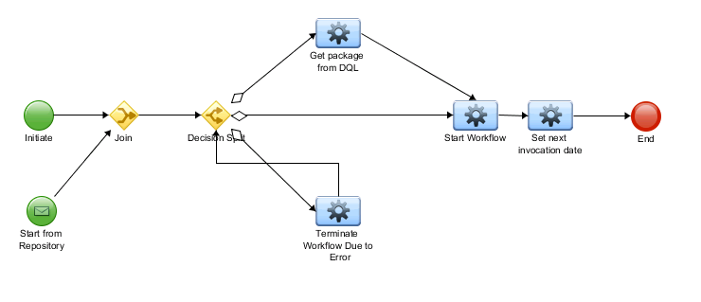

To trigger this workflow you must configure an Invocation Schedule business object. The following table describes the information needed.

|  |  |
| --- | --- |
| Data Field | Description |
| Configuration Name | The name of this schedule |
| Process Name | Name of the process that will be invoked. |
| Next Invocation Time | Date and time of next scheduled run time |
| Frequency | How often the workflow is triggered, the options are every minute, hour, day, month and last day of month. |
| Is Active | Whether this schedule is active |
| Package Delivery | If there are packages with the workflow, selecting DQL will all you to run a dql query for it. |
| Package Query | DQL query for package, see below for example |

For a DQL query, two columns are *always* required: package_name, component_id

Example query: Select 'package0' as 'package_name', r_object_id as 'component_id' from dm_document where object_name like '%myDoc%' enable(RETURN_TOP 1)